**Andy Nguyen**

**Assignment 3**

**Create a new word document that includes the following:**

**A link to your GitHub repository for a NEW project**

Submit screen shots of the following:

a. The project showing that you can view YOUR data tables in WebStorm

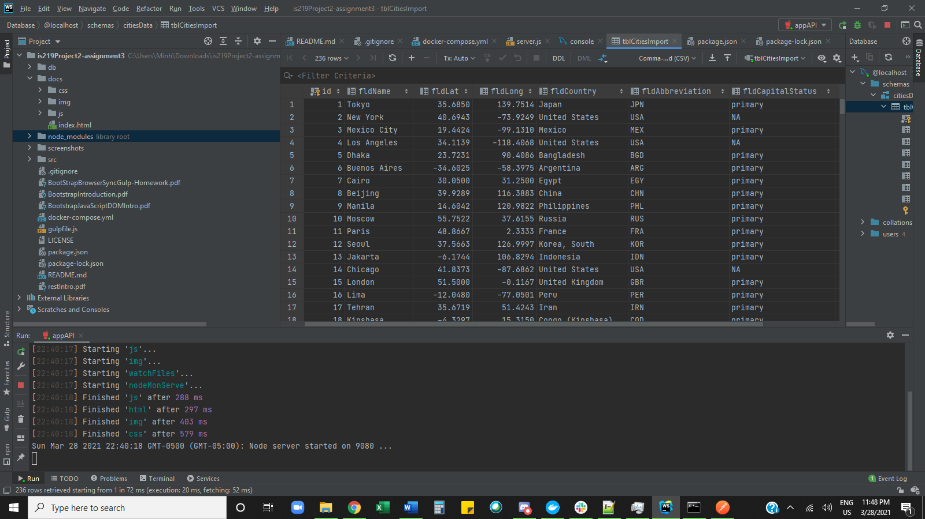

b. YOUR project running correctly in the browser displaying a data table

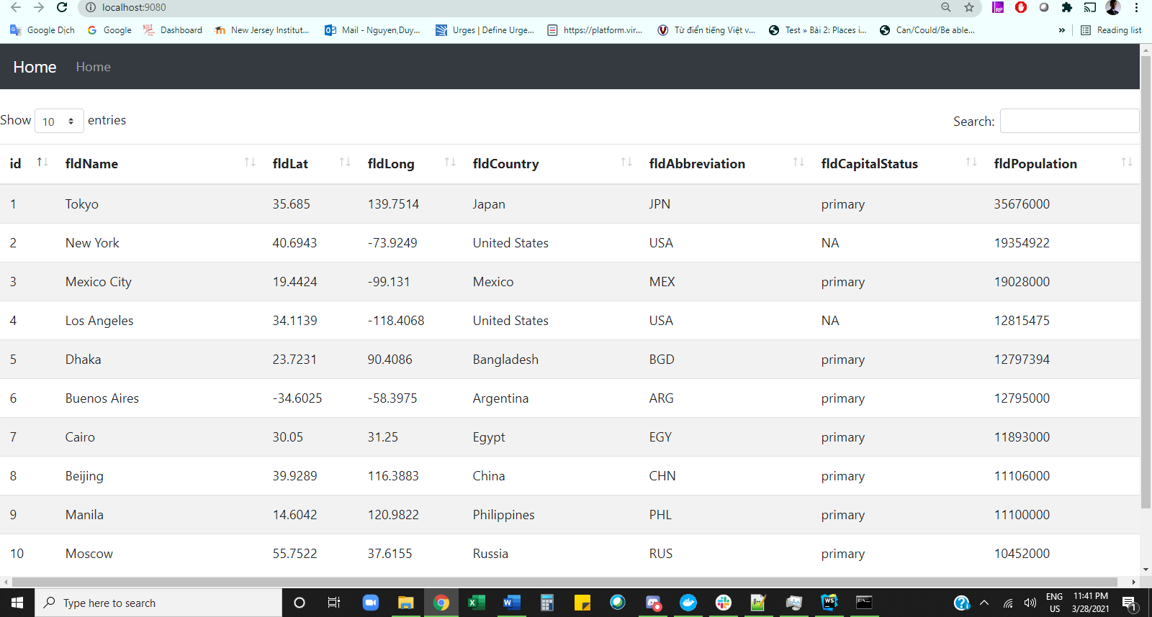

c. A screen shot of Postman and YOUR data returned from the project.

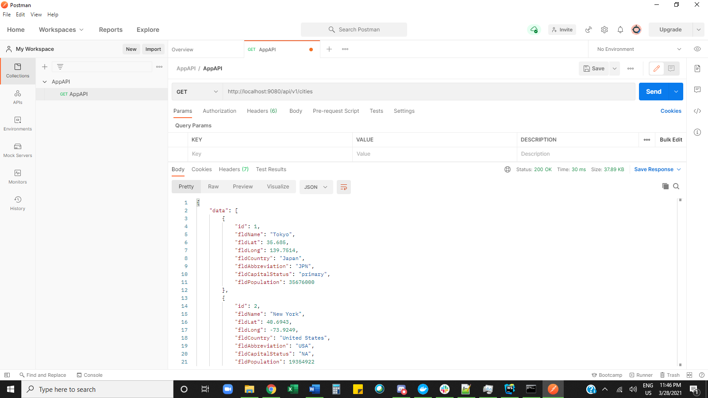

d. A screen shot of the browser console showing the XHR network request made from the browser when the page loads.

